FIN3080 HW2 REPORT

Q1:

1. Data processing:
2. For monthly P/B ratios (stock price/earnings per share), I use monthly stock close price/Quarterly net asset per share
3. Then I Exclude records with P/B ratios less than P/B ratio’s 5th percentile or greater than P/B ratio’s 95th percentile.
4. Then I delete the parent statement B for financial indicator data
5. And I drop the nan of ['ROE','Volatility',' PB ratio']
6. Finally, I do the regression.
7. Report and Discussion: 

β: [0.69645243 9.27757804]

α: -0.09172456475184809

1. We can know the β for ROE is about 0.696. It indicates that there is a positive correlation between ROE and PB ratios. The investor tends to be more willing to pay higher prices for companies with higher ROE. Because ROE reflects the profitability of a company after it has invested capital.
2. We can know the β for stock price volatility is about 9.277. It indicates that there is a strong positive correlation between stock price volatility and PB ratios. Investors are likely to invest in stocks that have higher volatility. Because higher volatility means more opportunities for earning profit. The CAPM tells us that higher risk means higher returns.

Q2:

1. Data processing:
2. For each month, I set 10 equal-weight groups for all the stocks according to their PB ratios of the last month.
3. Then I calculate the average return for 10 groups in every month.
4. Finally, I calculate the total average returns for the 10 groups and us e a bar chart to display it.

Report and Discussion: 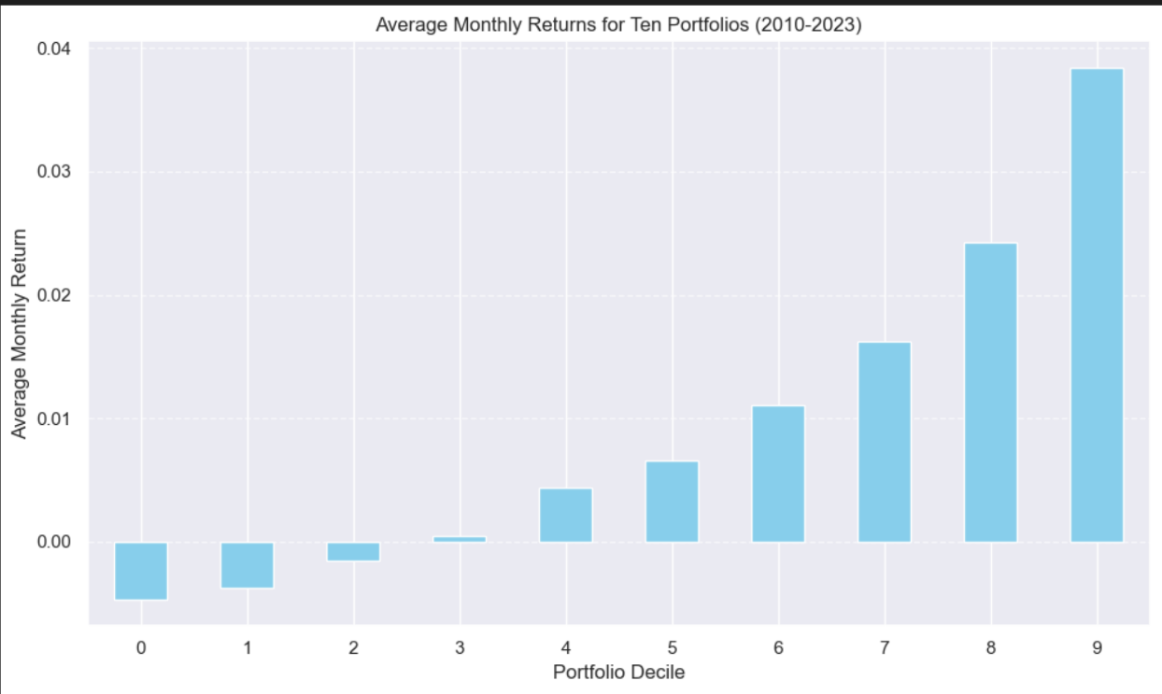

1. The chart shows that the group with higher last-month PB ratios usually gets higher returns
2. The last-month PB ratios can indicate the investors’ high valuation of the stock. The high market expectation and optimistic market sentiment may continue to drive up the stock price in the following month, leading to higher returns. It also reveals that the company may have more growth potential and a premium valuation.
3. Also, according to Q1’s conclusion, the higher last-month PB ratios may indicate a higher ROE. These companies might have a higher Return on Equity (ROE), indicating that they can effectively use shareholders' capital to generate profits, which can attract more investors, leading to an increase in stock prices.